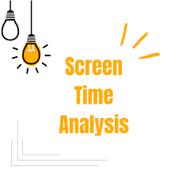

Business Problem:

The problem statement for the screen time analysis revolves around the increasing concern over mobile app usage and its implications on user behavior, mental health, and productivity. As individuals become more reliant on mobile devices, there is a pressing need to understand how users interact with various applications, particularly in terms of the time spent, frequency of app openings, and the influence of notifications. This project seeks to analyze screen time data to identify patterns and trends in user engagement across different applications, elucidating the relationship between notifications and app usage.